Welcome & Announcements, Friendship Information, & Sharing Christ’s Peace

Prelude: “Praise to the Lord” Medley
Let us prepare our hearts and minds for worship.

Call to Worship
Leader: Men and women, boys and girls, we are all one in the love of Christ.
People: We come together to worship the One Triune God of grace.
Leader: Each of us is unique and gifted, able to make a difference in the world.
People: We offer all that we are and all that we have to be used to the glory of God.

*Opening Hymn: “My Country, ‘Tis of Thee” Red Hymnal, #571

*Prayer of Confession (Unison)
God of grace and glory, we try to do our duty, to offer our best, to be all that you have called and created us to be. Sometimes we fail. Please forgive us and renew us by your Spirit. Help us to support one another and to serve you. Empower us to share the good news of our Savior Jesus Christ, in whose name we pray. Amen.

*Silent Reflection

*Assurance of Pardon

*Gloria Patri (Glory Be to the Father…) Red Hymnal, #623

Scripture Isaiah 42:1-9 (page 1124)
Luke 4:14-21 (page 1596)
Leader: The word of the Lord.
People: Thanks be to God.

Children's Time
Please join in singing one verse of Jesus Loves Me as the children come forward.

Special Music: “Here I Am, Lord”

Sermon “Mission Revealed” Rev. Kimby Young

*Profession of Faith The Apostle's Creed Red Hymnal, inside back cover

*Hymn “Come, All Christians, Be Committed” Red Hymnal, #455

Offertory: “The Servant Song” Gillard

*Doxology Red Hymnal, #625

*Prayer of Dedication & Pastoral Prayer Please Pray for the Family of Tom Rendleman, Nancy Jenkins, David Butler, Glenn Schulz, Scott & Cynthia Miller, Arlene Thompson, Keith W. Smith, Roland Jack, Rob Kuhauz, Denny Harris, Delphine Brawner, Carla Betik, Kyle Campbell, Minnie Ashmore, Mark Howard, Mr. & Mrs. Brad Hadel, Clay Simmons, Jano Smoor, John Kuhns, Richard Hatfield, Mark Freund, Jackson Tijerina, The DeWald Family, Austin W. Pennington

Communion & Celebration
Invitation
Great Thanksgiving
The Lord’s Prayer
Breaking of Bread
Communion of the People
Prayer of Thanksgiving

*Closing Hymn: “Let Us Break Bread Together” Red Hymnal, #323

*Benediction

Postlude: “Take My Life and Let it Be Consecrated” Malan

*Those who are comfortably able will please stand

Kimby Young, Pastor; Boy Scouts, Worship Assistant; Robyn Forkner, Pianist;
Todd Burd, Music Ministries; Alice Rollf, Organist;
Chancel Choir; Heather Rutler, Worship Transcription

Ushers February 2017
Jerry & Paula Waters; Phil Lenahan
Andy & Lois Barber; John Forkner

Congregational Life Pillar Meeting, February 6 at 7:00 PM
Bell Choir 6:00 – 7:00 PM; Chancel Choir 7:00 – 8:00 PM
Today, Sunday, February 5, Souper Bowl Collection, sponsored by EPIC.

Boy Scout Troop 88 Pancake Breakfast
Scout Sunday, today, February 5, 2017 7:00AM – 12:00 PM
$5.00 per person. Tickets will be available at the door. Pancake and Sausage

LADIES BIBLE STUDY
February we will be starting a new study! Registration table and details in the Narthex on February 5, 2017. The study will consist of 6-8 weeks, beginning February 23, 2017.

Annual Congregational Meeting has been called by Session for Sunday, February 12, at 10:00 AM, after regular worship service.

Congregation Potluck Brunch All members are asked to help provide brunch dishes.

Usher Training immediately following the Congregational meeting.

Men’s Breakfast at Perkins
Breakfast will be held at 7:00 AM on Tuesday, February 14, at Perkins Restaurant. The topic of “Mother Nature’s Materials” will be presented by Carl Frahme.

Sunday Evening Bible Study Class – 4:30-6:00 pm – 8 weeks – Starting February 19 and ending on Palm Sunday - Pastor Kimby will lead a short introduction to the New Testament. Guests and non-members are welcome.

Photo Directory Sign Ups – New day added Professional pictures will be taken on February 21, 22 and 23. Please sign up in the narthex today.

World Day of Prayer
World Day of Prayer will be held in the sanctuary on Friday, March 3, 2017, at 1:00 PM.

DVDs (videos) & CDs (audio/music only) of Cooper McGuire’s Jan. 8th Concert are now available in the church office. So, if you missed the concert (or want to hear it again), please stop in. Donations toward costs are appreciated, but not necessary.

Sunday
February 5, 2017
Boy Scout Sunday
9:00 AM
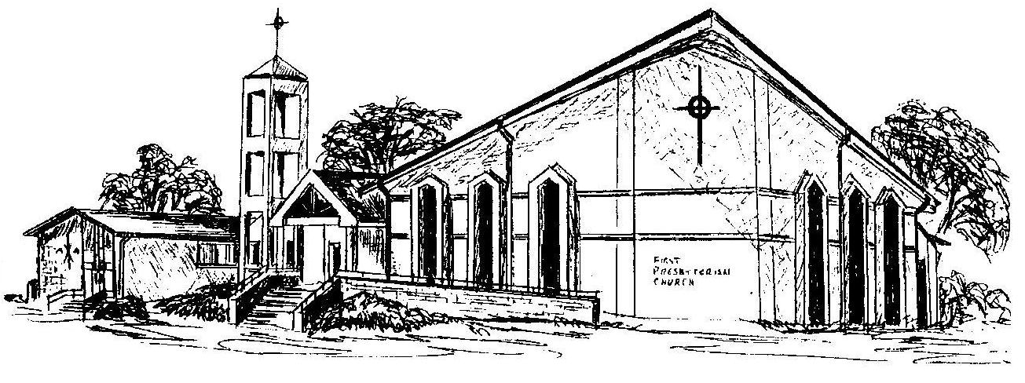

First Presbyterian Church
In the heart of Gardner since 1866 ~ Serving from the heart of God

Welcome - Thank you for joining us for worship today. Please fill out a visitor information card found in the pew racks and place those in the offering plate so that we may follow up with you in the future. Your presence with us today has been a blessing to us, we hope that you have felt the presence of God and the welcome of this congregation.

