Welcome & Announcements, Friendship Information, & Sharing Christ’s Peace
Prelude: “Praise the Lord” Medley
Let us prepare our hearts and minds for worship.

Call to Worship
Leader: Let us gather in the awareness of God's love!
People: God's love has brought us here and made of us a church!
Leader: We can live with confidence and hope!
People: In the assurance that we are loved by the Lord!
Leader: Lord, we offer our hearts now in worship!

*Opening Hymn: “Praise to the Lord, the Almighty” Red Hymnal, #8

* Prayer of Confession (Unison)
Almighty God, you love us, but we have not loved you; you call, but we have not listened.
We walk away from neighbors in need, wrapped up in our own concerns. We have gone along with evil, with prejudice, and greed. Lord, help us to face up to ourselves, so that as you move toward us in mercy, we may change, turn to you and receive forgiveness.

*Silent Confession

*Assurance of Pardon
Leader: Christ Jesus entered the world to rescue sinners. He personally bore our sins in his body on the cross, so that we might be dead to sin and be alive to all that is good. Friends, believe the good news of the gospel.
People: In Jesus Christ, we are forgiven! Alleluia! Amen!

*Gloria Patri (Glory Be to the Father…) Red Hymnal, #623

Scripture Ephesians 3:14-21 (page 1820)
Leader: The word of the Lord.
People: Thanks be to God.

Children's Time "I Am Loved"

Special Music “One Small Child” J. J. Briscoe

Scripture I John 4:7-12 (page 1902)

Sermon: "We Belong to God! No One Else Has A Vote in the Matter" Rev. Larry Thornton

*Profession of Faith The Apostle's Creed Red Hymnal, inside back cover

*Hymn “O the Deep, Deep Love of Jesus” verses 1, 2, 5 Red Hymnal, #212

Pastoral Prayer & Lord’s Prayer: Nancy Jenkins, David Butler, Glenn Schulz, Scott & Cynthia Miller, Arlene Thompson, Keith W. Smith, Roland Jack, Rob Kuhauz, Denny Harris, Delphine Brawner, Carla Betik, Kyle Campbell, Minnie Ashmore, Mark Howard, Mr. & Mrs. Brad Hadel, Clay Simmons, Jano Smoor, John Kuhns, Richard Hatfield, Mark Freund, Jackson Tijerina, The DeWald Family, Austin W. Pennington

Offertory: “O How He Loves You and Me” K. Kaiser

*Doxology Red Hymnal, # 625

*Prayer of Dedication

*Closing Hymn: “They'll Know We Are Christians by Our Love” Red Hymnal, #284

*Benediction
Wherever you go, God is sending you. Wherever you are, God has put you there. God has a purpose in your being there. Christ who indwells you has something he wants to do through you where you are. Believe this and go in his grace and love and power!
--Richard C. Halverson, former chaplain of the U.S. Senate

Postlude: “Lord, I Lift Your Name on High” R. Founds

*Those who are comfortably able will please stand

Rev. Dr. Larry Thornton, Pastor; Larry Schick, Worship Assistant;
Robyn Forkner, Pianist; Todd Burd, Music Ministries; Alice Rollf, Organist;
Special Music, J. J. Briscoe; Heather Rutler, Worship Transcription

Ushers:
Kim & Karen Liu; Julie Sutton; Phil & Lisa Culbertson; Tom Corwin

Sunday, January 29, Blood drive in Fellowship Hall 8:30 – 2:30 PM
Our guest preacher today is the Rev. Larry Thornton. Rev. Thornton is an ordained Presbyterian minister who has served several congregations and chaplain of Aberdeen Village, a Presbyterian Manor retirement community in Olathe, KS. Rev. Thornton is retired. We welcome Rev. Thornton to our pulpit and look forward to his message from God’s Word today!

Boy Scout Troop 88 Pancake Breakfast
Scout Sunday, February 5, 2017 7:00AM – 12:00 PM
$5.00 per person. Tickets will be available at the door. Pancake and Sausage

LADIES BIBLE STUDY
February we will be starting a new study! Registration table and details in the Narthex on February 5, 2017. The study will consist of 6-8 weeks, beginning February 23, 2017.

Annual Congregational Meeting has been called by Session for Sunday, February 12, at 10:00 AM, after regular worship service.

Congregation Potluck Brunch All members are asked to help provide brunch dishes.

Usher Training immediately following the Congregational meeting.

Men’s Breakfast at Perkins
Breakfast will be held at 7:00 AM on Tuesday, February 14, at Perkins Restaurant. The topic of “Mother Nature’s Materials” will be presented by Carl Frahme.

Sunday Bible Study Class – 4:30-6:00 pm – 8 weeks – Starting February 19 and ending on Palm Sunday - Pastor Kimby will lead a short introduction to the New Testament.
Guests and non-members are welcome.

Photo Directory Sign Ups - Professional pictures will be taken on February 22 and 23 from 2:00 – 8:45 p.m. Please sign up in the narthex today, Sunday, January 29.

World Day of Prayer
World Day of Prayer will be held in the sanctuary on Friday, March 3, 2017, at 1:00 PM.

DVDs (videos) & CDs (audio/music only) of Cooper McGuire’s Jan. 8th Concert are now available in the church office. So, if you missed the concert (or want to hear it again), please stop in. Donations toward costs are appreciated, but not necessary.

Sunday, January 29, 2017
9:00 AM

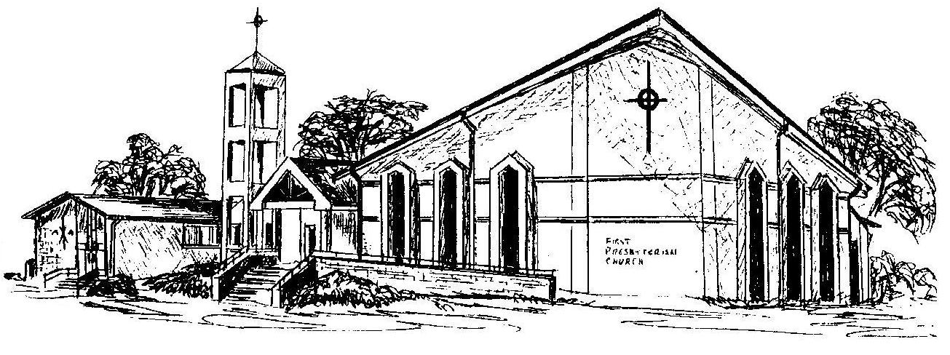

First Presbyterian Church
In the heart of Gardner since 1866 ~ Serving from the heart of God

Welcome - Thank you for joining us for worship today. Please fill out a visitor information card found in the pew racks and place those in the offering plate so that we may follow up with you in the future. Your presence with us today has been a blessing to us, we hope that you have felt the presence of God and the welcome of this congregation.

