Welcome & Announcements, Friendship Information, & Sharing Christ’s Peace
Prelude: “Song of Praise” J. S. Bach
Let us prepare our hearts and minds for worship.

Call to Worship -
Leader: In the beginning, God’s Spirit moved over the waters.
People: Even today, the Spirit of God moves through water to remind us of God’s grace.
Leader: In baptism we are touched by God’s Spirit, enfolded in a community of grace, and empowered to go forth sharing God’s love in the world.
People: Let us celebrate God’s grace, remembering Jesus’ baptism, renewing our own baptisms, and accepting our call to serve God in Jesus Christ our Lord.

*Opening Hymn: “All Beautiful the March of Days” Blue Hymnal, #292
* Prayer of Confession (Unison)
O God, who created us whole, we come in our brokenness to remember that we have been baptized. You have reclaimed us by water and the Holy Spirit’s fire, but we have wandered far from the inspiration you provide. We have sought power by our own manipulations rather than accept the strength you alone can provide. Refashion us in your image and empower us once more to follow Jesus as true disciples. Amen.

*Silent Confession

*Assurance of Pardon

*Gloria Patri (Glory Be to the Father…) Blue Hymnal, #567

Scripture Matthew 3:13-17 (page 1499)
Romans 6:3-11 (page 1754)
Leader: The word of the Lord.
People: Thanks be to God.

Children's Time
Please join in singing one verse of Jesus Loves Me as the children come forward.
Sermon: “Newness of Life” Rev. Kimby Young

*Profession of Faith The Apostle's Creed Blue Hymnal, top page 14
*Hymn “Baptized in Water” Blue Hymnal, #492

Reaffirmation of Baptism Covenant:
Trusting in the gracious promises of God, do you renounce sin and the power of evil in your life and in the world?
Do you turn again to Jesus Christ and accept him as your Lord and Savior?
Do you intend to be Christ's faithful disciple, obeying God’s Word and showing God’s love?
Pastoral Prayer & Lord’s Prayer: Arlene Thompson, Keith W. Smith, Glenn Schulz, Roland Jack, Rob Kuhauz, Denny Harris, Delphine Brawner, Carla Betik, Cynthia Miller, Kyle Campbell, Minnie Ashmore, Mark Howard, Mr. & Mrs. Brad Hadel, Scott Miller, Clay Simmons, Jano Smoor, John Kuhns, Richard Hatfield, Mark Freund, Jackson Tijerina, The DeWald Family, Austin W. Pennington

Offertory: “Peace in My Soul” J. Hughes

*Doxology Blue Hymnal, #592

*Prayer of Dedication

*Closing Hymn: “I’ve Got Peace Like a River” Blue Hymnal, #368

*Benediction

Postlude: “Recessional and Hymn” Boalt

*Those who are comfortably able will please stand

Kimby Young, Pastor; Tina Fraser, Worship Assistants;
Robyn Forkner, Pianist; Todd Burd, Music Ministries; Alice Rollf, Organist;
Heather Rutler, Worship Transcription

Ushers:
Kim & Karen Liu; Julie Sutton; Phil & Lisa Culbertson; Tom Corwin

Sunday, January 15, Sunday School 10:15 AM
Sunday, January 15: Discipleship Pillar Meeting 11:15 AM
Sunday, January 15, Traveling Day Camp 12:00 PM
Monday, January 16: PW Meeting 7:00 PM

Annual Report Due on January 19, 2017.

Elder Officer Retreat on Saturday, January 21 in the Fellowship Hall 9:00 – 12:00 PM.

Per Capita for the Year 2017
Per capita was approved at the stated meeting of the presbytery. Anyone wishing to contribute money to cover expenses for their family or even for additional members who cannot pay, may write a check to First Presbyterian Church and mark it for per capita.
The total per member is $41.96, and it is broken down as follows:
General Assembly $7.50; Synod $2.80; Presbytery $31.66

Photo Directory – Volunteers needed. If you would be willing to work on the upcoming photo directory, contact Connie or Kimby.

New Member Inquiry A small group of individuals will be joining First Presbyterian Church in next Sunday. If you would like to know more about membership or would like to join, please contact Pastor Kimby Young.

Vacation Week
Pastor Kimby Young will be taking a vacation week from January 24-31. Rev. Larry Thornton will be filling the pulpit on January 29. For emergencies Kimby will be accessible through Connie Crabbs in the office.

Boy Scout Troop 88 1st Annual Chili Feed & Silent Auction
Saturday, January 28, 2017, 3:00 – 6:00 PM. First Presbyterian Church
$5.00 per person. Tickets available at the door. Beef & Chicken Chili and hotdogs for the kiddos.

Annual Congregational Meeting has been called by Session for Sunday, February 12, at 10:00 AM, after regular worship service.

Sunday, January 15, 2017
9:00 AM

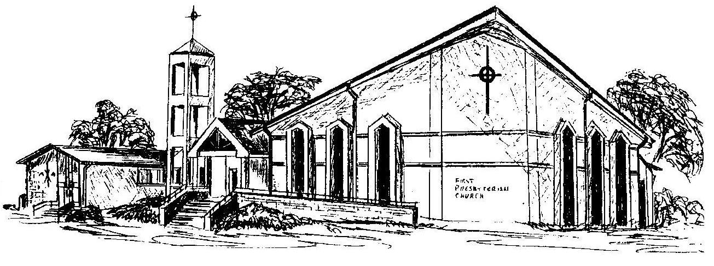

First Presbyterian Church
In the heart of Gardner since 1866 ~ Serving from the heart of God

Welcome - Thank you for joining us for worship today. Please fill out a visitor information card found in the pew racks and place those in the offering plate so that we may follow up with you in the future. Your presence with us today has been a blessing to us, we hope that you have felt the presence of God and the welcome of this congregation.

