Welcome & Announcements, Friendship Information, & Sharing Christ’s Peace
Prelude: Ceremonial Rondeau H. Purcell
Let us prepare our hearts and minds for worship.

Call to Worship -
Leader: People of God, rejoice! The Light of the World has come!
People: The light shines in the darkness, and the darkness has not overcome it.
Leader: People of God, give thanks! We have received this Light of life and are called to share God’s light in the world.
People: Arise, Shine, Our Light has come!

*Opening Hymn: O Splendor of God's Glory Bright Blue Hymnal, #474
* Prayer of Confession (Unison) (From the Book of Common Worship (1993), PCUSA)
God of Glory, you sent Jesus among us as the light of the world, to reveal your love for all people. We confess that our sin and pride hide the brightness of your light. In your mercy, cleanse us of our sin, and baptize us once again with your Spirit, that, forgiven and renewed, we may show forth your glory shining in the face of Jesus Christ. Amen.

*Silent Confession

*Assurance of Pardon

*Gloria Patri (Glory Be to the Father…) Blue Hymnal, #579

Scripture Isaiah 60:1-6 (page 1155)
Matthew 5:14-16 (page 1501)
Matthew 2:1-12 (page 1497)
Leader: The word of the Lord.
People: Thanks be to God.

Children's Time
Please join in singing one verse of Jesus Loves Me as the children come forward.

Special Music: “Breath of Heaven” Ella Falkner by Amy Grant

Sermon: “Rise and Shine” Rev. Kimby Young
Jesus said, “I am the light of the world. Whoever follows me will never walk in darkness, but will have the light of life.” John 8:12

*Profession of Faith The Apostle's Creed Blue Hymnal, top page 14
Installation of Deacon’s: Jessica Brunker; Denise Bockus
Thank Elders Retiring: Karl Allen, Debbie McGuire, Nancy Falkner
Thank Deacons Retiring: Char Bergene, Shirley Harley

*Hymn O Word of God Incarnate Blue Hymnal, # 327

Pastoral Prayer & Lord’s Prayer: Keith W. Smith, Glenn Schulz, Roland Jack, Rob Kuhauz, Denny Harris, Delphine Brawner, Carla Betik, Cynthia Miller, Kyle Campbell, Minnie Ashmore, Mark Howard, Mr. & Mrs. Brad Hadel, Scott Miller, Clay Simmons, Jano Smoor, John Kuhns, Richard Hatfield, Mark Freund, Jackson Tijerina, The DeWald Family, Austin W. Pennington

Offertory: Bring We the Frankincense of Our Love Carmichael

*Doxology Blue Hymnal, # 592

*Prayer of Dedication

*Closing Hymn: Arise Your Light is Come Blue Hymnal, #411

*Benediction

Postlude: Arise, Shine O'Brien / Davis
*Those who are comfortably able will please stand

Kimby Young, Pastor; Kim Allen, Worship Assistants;
Robyn Forkner, Pianist; Todd Burd, Music Ministries; Alice Rollf, Organist;
Special Music, Ella Falkner; Heather Rutler, Worship Transcription

Ushers:
Kim & Karen Liu; Julie Sutton; Phil & Lisa Culbertson; Tom Corwin

Please pray for the family of Joyce Kelly, died on Wednesday, December 21. Husband Joe and daughter JoLynn Clark.

Please pray for the family of Mary Harris, died on Tuesday, January 3. Funeral services are pending in Blue Mound, KS. Mary is the aunt of Juanita Murrow, she turned 93 on Christmas Day.

Please pray for the family of Delphine Brawner, died on Tuesday, January 3. Delphine or Aunt Dick is the aunt of Eldonna Chesnut.

Sunday, January 8: Mission Pillar Meeting 11:15 AM
Monday, January 9: Session 6:30 PM
Tuesday, January 10: Men’s Breakfast Perkin’s 7:30 AM

Sunday School for all ages Resumes on today at 10:15 AM

Cooper McGuire Free Fundraising Concert in the Sanctuary – today at 2:30 PM.
Cooper invites all congregation and community members as well as their families, friends, and “lovers of music” to his upcoming concert, where he will be performing various vocal and piano selections and sharing some of his adventures as a K-State student. Cooper has been invited to travel to Ireland from May 15-24 as a member of the Kansas State University Choirs to represent Kansas in the American Festival of Music. There are no tickets or cost to attend this concert, however any donations will help Cooper go on this trip and would be greatly appreciated.

Men’s Breakfast at Perkins
The First Presbyterian Men’s Breakfast will be held at 7:30 AM on Tuesday, January 10, at Perkins Restaurant. Hope to see you!

Per Capita for the Year 2017
Per capita was approved at the stated meeting of the presbytery. Anyone wishing to contribute money to cover expenses for their family or even for additional members who cannot pay, may write a check to First Presbyterian Church and mark it for per capita.
The total per member is $41.96, and it is broken down as follows:
General Assembly $7.50; Synod $2.80; Presbytery $31.66

Photo Directory – Volunteers needed. If you would be willing to work on the upcoming photo directory, contact Connie or Kimby.

New Member Inquiry A small group of individuals will be joining First Presbyterian Church in January or early February. If you would like to know more about membership or would like to join, please contact Pastor Kimby Young. We will set a gathering time based on the schedules of those who have expressed interest.

Vacation Week
Pastor Kimby Young will be taking a vacation week from January 24-31. Rev. Larry Thornton will be filling the pulpit on January 29. For emergencies Kimby will be accessible through Connie Crabbs in the office.

Sunday, January 8, 2017
9:00 AM

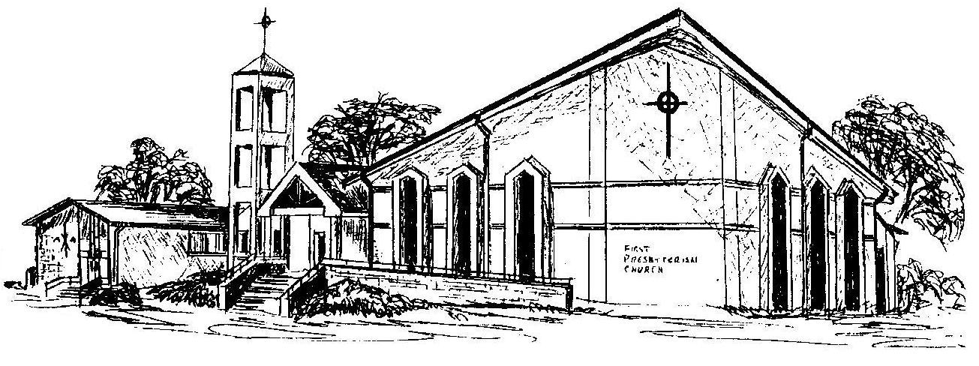

First Presbyterian Church
In the heart of Gardner since 1866 ~ Serving from the heart of God

Welcome - Thank you for joining us for worship today. Please fill out a visitor information card found in the pew racks and place those in the offering plate so that we may follow up with you in the future. Your presence with us today has been a blessing to us, we hope that you have felt the presence of God and the welcome of this congregation.

