Welcome
Prelude “Near His Cross” Bonita L. Luciotti
Let us prepare our hearts and minds for worship.

Call to Worship
Leader: We see a cross before us and gather to worship.
People: We remember a cross on a hill far away and we thank God for life.
Leader: We hear Jesus call us to take up our cross to follow and we wonder what that means.
People: Let us seek Jesus Christ and receive God’s grace as we worship together today.

*Opening Hymn: “In the Cross of Christ I Glory” Red Hymnal, #184

*Prayer of Confession (Unison) (adapted from RE-Worship Blog)
Merciful God, you call us to follow; to turn away from our own selfish interests, and to take up our cross and follow after You. You call us to follow, even if the path is difficult to see, or is heading in a direction we would never have chosen for ourselves. Forgive us for being so quick to question and so hesitant to follow. Help us to see with the eyes of faith. Teach us to follow without fear, knowing that You are always with us, leading the way. Amen.

Silent Reflection

*Assurance of Pardon

* Gloria Patri (Glory Be to the Father…) Red Hymnal, #623

Children’s Time

Scripture “Matthew 10:32-39” (page 1512)
“Luke 9:23-27” (page 1609)
Leader: The word of the Lord.
People: Thanks be to God.

Solo “Be Thou My Vision” Irish Folk Hymn

Sermon “Take Up Your Cross” Rev. Kimby Young

*Profession of Faith The Apostle's Creed Red Hymnal, inside back cover
I Believe in God the Father Almighty, Maker of heaven and earth, And in Jesus Christ his only Son our Lord; who was conceived by the Holy Ghost, born of the Virgin Mary, suffered under Pontius Pilate, was crucified, dead, and buried; he descended into hell; the third day he rose again from the dead; he ascended into heaven, and sitteth on the right hand of God the Father Almighty; from thence he shall come to judge the quick and the dead. I believe in the Holy Ghost; the holy catholic Church; the communion of saints; the forgiveness of sins; the resurrection of the body; and the life everlasting. Amen

*Hymn “Beneath the Cross of Jesus” Red Hymnal, # 183

Pastoral Prayer & Lord’s Prayer

Offertory Meditation “Morning Prayer” Walter O'Donnell

*Doxology

*Prayer of Dedication

*Closing Hymn: “The Old Rugged Cross” Red Hymnal, #186

*Benediction

Postlude “March Recessional” Lily Strickland
*Those who are comfortably able will please stand.

Rev. Kimby Young, Pastor; Mitch McSwane, Worship Assistant
Dean Faulk, Music Ministries, Alice Rollf, Organist; Chesley Jones, Solo
Mike McGuire and Brad Cornell, Slide Production
Theo Borge, Tech and Videographer; Kim Liu, Sound

Childcare is always available in the nursery (off the hall to the west of the sanctuary). Children are welcome to stay in the sanctuary thru the whole service, or to leave at any time. Allison Perry is our primary childcare attendant.

Offering Plates are at the entrance of each aisle for your contributions to the work of the church.

Gardner Multi Service Center collection is ongoing every week and is always in need of any non-perishable food. Bring something every week or once a month.

Fair Trade Products for Sale on Sundays Coffee, tea, chocolate, nuts, olive oil, dried fruit, baking products, and a few other items are for sale each Sunday at church.

Harvesters Food Distribution is always seeking volunteers. Every 3rd Saturday at Trade Net Parking lot and every 4th Wednesday at Divine Mercy Parish. Distribution begins at about 1 p.m.

Monday Night Bible Study group has started a new study: Angels: 8 Studies for Individuals or Groups, on Feb. 12. This group meets every other Monday evening at 5:30pm via Zoom. If interested, please contact Jennifer Waites (jwaitemail@hotmail.com).

OGHS collection is received on March 31, Easter – 0r anytime before. Mark check OGHS.

Mission fundraiser for hygiene kits $5.00, woman/girls health kits $25.00.

Black Out Drapes - For Lent each year we raise curtains over the stained glass windows as reminders of the deepening season. As a Lenten discipline we are called to awareness of light and darkness in the world as we seek God's presence in our daily lives, and as we look forward in hope to the celebration of the resurrection of Jesus Christ

Holy Week Worship Schedule and Scripture
March 24 – Palm Sunday 8:45 and 11:00 a.m.; Fellowship Hour between services
March 28 – Mandy Thursday 7:00 p.m. Worship & Communion – John 13: 1-7, 31-35
March 29 – Good Friday – 7:00 p.m. Worship Service – Mark 15:16-39
March 31 – Easter – two services – 8:45 a.m. and 10:30 a.m. Celebration of the Resurrection

Session has established a "Suggestion Box" just outside the office for ideas, comments, questions and thoughts. Contents will be reviewed at session meetings on the 2nd Monday of each month. Names are helpful if we need to follow up, but you may remain anonymous.

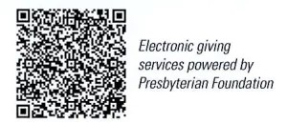
First Presbyterian Church
In the heart of Gardner since 1866 ~ Serving from the heart of God

Sunday, March 17, 2024
5th Sunday of Lent
8:45 AM
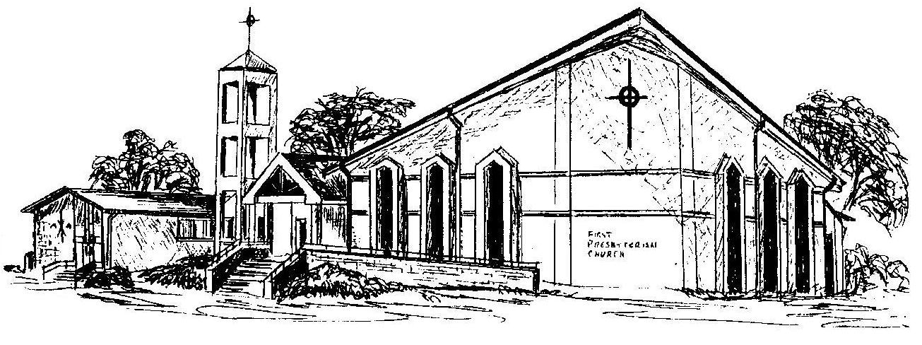

Welcome - Thank you for joining us for worship today. Please fill out a visitor information card found in the pew racks and place those in the offering plate so that we may follow up with you in the future. Your presence with us today has been a blessing to us, we hope that you have felt the presence of God and the welcome of this congregation.

