Welcome
Prelude “Worship” James Southbridge
Let us prepare our hearts and minds for worship.

Call to Worship
Leader: We gather this day in many conditions. Some are whole, some are broken.
People: All are loved by God.
Leader: We praise God today for all the ways God has blessed and healed us.
People: We come together to share the blessings we have received.

*Opening Hymn “Sing Praise to God” Red Hymnal, #6

*Prayer of Confession (Unison)
God of Miracles and Mercy, thank you for loving us. Sometimes we come to worship out of habit, not really expecting much to happen. Sometimes we hear the stories from scripture of healing and transformation, and we think that doesn’t happen today. Forgive us. Open our eyes to your miracles all around us. Inspire us to believe all that you can do and bring about through us. Help us to believe and to move forward in faith in the name of Jesus Christ our Healer and Redeemer. Amen.

*Silent Reflection

*Assurance of Pardon

*Gloria Patri (Glory Be to the Father…) Red Hymnal, #623

Children’s Time

Scripture “John 5:2-9” (page 1653)
“John 9:1-11” (page 1664)
Leader: The word of the Lord.
People: Thanks be to God.

Anthem “On Eagle’s Wings”
Michael Joncas, arr. by Douglas E. Wagner

Sermon “Healing and Community” Rev. Kimby Young

*Profession of Faith The Apostle's Creed Red Hymnal, inside back cover
I Believe in God the Father Almighty, Maker of heaven and earth,
And in Jesus Christ his only Son our Lord; who was conceived by the Holy Ghost, born of the Virgin Mary, suffered under Pontius Pilate, was crucified, dead, and buried; he descended into hell; the third day he rose again from the dead; he ascended into heaven, and sitteth on the right hand of God the Father Almighty; from thence he shall come to judge the quick and the dead.
I believe in the Holy Ghost; the holy catholic Church; the communion of saints; the forgiveness of sins; the resurrection of the body; and the life everlasting. Amen

*Hymn “They’ll Know We Are Christians By Our Love” Red Hymnal, #284

Pastoral Prayer & Lord’s Prayer

Offertory Meditation: “Heal Me, Hands of Jesus” Norman L. Warren

*Doxology

*Prayer of Dedication

*Closing Hymn: “Leaning on the Everlasting Arms” Red Hymnal, #354

*Benediction

Postlude “A Time for New Beginnings” Lani Smith
*Those who are comfortably able will please stand.

Rev. Kimby Young; Kim Allen, Worship Assistant
Dean Faulk, Music Ministries, Alice Rollf, Organist, Chancel Choir
Mike McGuire and Brad Cornell, Slide Production
Davis Tropansky & Theo Borge, Tech, and Videographer; Kim Liu, Sound

Childcare is always available in the nursery (off the hall to the west of the sanctuary). Children are welcome to stay in the sanctuary thru the whole service, or to leave at any time. Allison Perry is our primary childcare attendant.

Offering Plates are at the entrance of each aisle for your contributions to the work of the church.

Gardner Multi Service Center collection is ongoing every week and is always in need of any non-perishable food. Bring something every week or once a month.

Fair Trade Products for Sale on Sundays Coffee, tea, chocolate, nuts, olive oil, dried fruit, baking products, and a few other items are for sale each Sunday at church.

Harvesters Food Distribution is always seeking volunteers. Every 3rd Saturday at Trade Net Parking lot and every 4th Wednesday at Divine Mercy Parish. Distribution begins at about 1 p.m.

2024 Per Capita is $43.29 The allocation breakdown is as follows General Assembly $7.73, Synod $2.80, Presbytery $32.76

Sunday January 28 at 9:45 a.m. Annual Congregational Meeting The session has called a congregational meeting for Sunday, January 28 at 9:45 a.m. The purpose of the meeting is to receive our annual reports from staff, committees, groups, and pillars, and to approve the terms of call for pastor Kimby Young.

Weather Cancellation Policy Usually, we try to worship if possible. We may modify worship or cancel Sunday school. Even if we don’t cancel. Be smart. Be cautious. Don't take any chances. Even if a church event is not cancelled, if you do not feel comfortable getting out, you are excused. If you have a duty, we will find someone to cover for you.

Souper Bowl Sunday February 11 Bring non-perishable food anytime.

Ash Wednesday, February 14 Worship Service is 7:00 – 8:00 p.m. Drive through prayer and sacrament – 5:30-6:30 p.m.

Presbyterian Women Bible Study starts on Thursday, February 1, at 7:00 p.m.in Fellowship Hall lesson is “Worth More Than Rubies” by Christina Patterson.

Monday Night Bible Study group is starting a new study: Angels: 8 Studies for Individuals or Groups, on Feb. 12. This group meets every other Monday evening at 5:30pm via Zoom. If interested, please contact Jennifer Waites (jwaitemail@hotmail.com).

First Presbyterian Church
In the heart of Gardner since 1866 ~ Serving from the heart of God

Sunday, January 28, 2024
8:45 AM

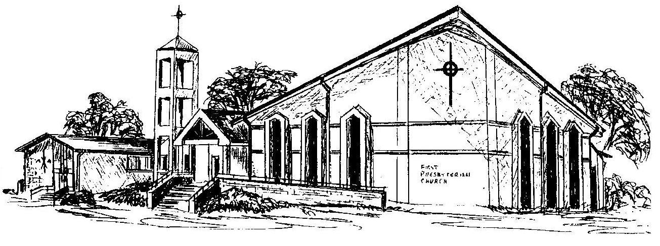

Welcome - Thank you for joining us for worship today. Please fill out a visitor information card found in the pew racks and place those in the offering plate so that we may follow up with you in the future. Your presence with us today has been a blessing to us, we hope that you have felt the presence of God and the welcome of this congregation.

