Welcome

Prelude “Holy, Holy, Holy” John B. Dykes
Let us prepare our hearts and minds for worship.

Call to Worship
Leader: For all the saints who have gone before us,
who have spoken to our hearts and touched our lives,
People: We praise you, God of the past!
Leader: For all the saints who live beside us,
whose weaknesses and strengths are woven with our own,
People: We praise you, God of the present!
Leader: For all the saints who live beyond us,
who challenge us to change the world with them,
People: We praise you, God of the future!

*Opening Hymn: “For All The Saints” Red Hymnal, #546

Remembrance of the Saints and Lighting of the Candles
Susie Lane, Nancy Webb, Doris Vervynck, Nadine Larrick, Alene Anderson, Barbara Donvan

Unison Prayer
Gracious God, we praise you for the glorious company of the saints who now rest with you. We thank you today for those who have departed from this life over the past year, and remember them in gratitude. We pray your blessing on their loved ones and on all of us who remember. Grant us your peace and confidence in you. We pray in witness to the resurrection of Jesus Christ and in the hope of that eternal union you have promised for all who believe in you. Amen.

*Gloria Patri (Glory Be to the Father…) Red Hymnal, #623

Children’s Time

Scripture “Isaiah 25:6-9” (page 1095)
“Hebrews 12:1-2” (page 1877)
“Revelation 7:9-17” (page 1921)
Leader: The Word of the Lord.
People: Thanks be to God.

Music “Arise, My Soul, Arise” Dan Forrest

Sermon: “Places in the Heart” Rev. Kimby Young
*Profession of Faith The Apostle's Creed Red Hymnal, inside back cover
I Believe in God the Father Almighty, Maker of heaven and earth,
And in Jesus Christ his only Son our Lord; who was conceived by the Holy Ghost, born of the Virgin Mary, suffered under Pontius Pilate, was crucified, dead, and buried; he descended into hell; the third day he rose again from the dead; he ascended into heaven, and sitteth on the right hand of God the Father Almighty; from thence he shall come to judge the quick and the dead.
I believe in the Holy Ghost; the holy catholic Church; the communion of saints; the forgiveness of sins; the resurrection of the body; and the life everlasting. Amen

*Hymn “The Day of Resurrection” Red Hymnal, #226

Offertory Meditation: “In Sacred Memory” Donald Lee Moore

*Doxology

The Sacrament of Holy Communion and Remembrance of Saints
(All bread is gluten free. Prepacked elements are available in the back)
Invitation
Great Prayer and The Lord’s Prayer
Words of Institution – Breaking of Bread
Communion of the People
Prayer of Thanksgiving

*Closing Hymn: “In Remembrance” Red Hymnal, #322

*Benediction

Postlude “For All the Saints”
Ralph Vaughan Williams /arr, Lani Smith
*Those who are comfortably able will please stand.

Rev. Kimby Young, Pastor; Randy & Sandy Rieger, Worship Assistant
Dean Faulk, Music Ministries, Chancel Choir
Alice Rollf, Organist
Mike McGuire and Brad Cornell, Slide Production
Davis Tropansky, Tech and Videographer; Kim Liu, Sound

Childcare is available in the nursery (off hall west of the sanctuary). Children are welcome to stay in the sanctuary, or to leave at any time. Allison Perry is our primary childcare attendant.

Offering Plates are at the entrance of each aisle for your contributions to the work of the church.

Gardner Multi Service Center collection is ongoing every week and is always in need of any non-perishable food. Bring something every week or once a month.

Fair Trade Products for Sale on Sundays Coffee, tea, chocolate, nuts, olive oil, dried fruit, baking products, and a few other items are for sale each Sunday at church.

Harvesters Food Distribution is always seeking volunteers. Every 3rd Saturday at Trade Net Parking lot and every 4th Wednesday at Divine Mercy Parish. Distribution begins at about 1 p.m.

FPC at the Joy Closet on the 4th Saturday of every month. Come anytime 10:00 – 2:00 p.m.

Choirs meet on Wednesday’s Bell Choir at 6:00 p.m. in Chapel, Chancel Choir at 7:00 p.m. in Sanctuary, Christmas Cantata at 8:00 p.m.

Give Thanks to the Lord, Stewardship Dedication Sunday, November 12. Financial Support, time, talents, property and prayer. Bring your Pledge card.

Operation Christmas Child Packing Party – November 12 – 9:45-11 a.m.
YOU ARE ALL INVITED TO A PACKING PARTY for Operation Christmas Child.

Congregational Meeting, Sunday, November 26 9:40 a.m. Session has called a congregational meeting for the purpose of electing officers for 2024. Elder nominees include Ginger Crist, Lynn Moldrup, Larry Schick, and Poppy Zurcher. Deacon nominees are Sandy Nellor, Joseph Kioko and Judy Mason, as well as Shana Devlin and Kelly Johnson renewing for a second term. Nominating Committee members at large for 2024 will also be elected.

Presbyterian Women’s Thank Offering will be on Sunday, November 19.

Presbyterian Women have up the Mitten Tree. Please bring scarves, gloves, mittens winter items. They will be delivered to different Gardner schools.

Presbyterian Women are having a Holiday High Tea Christmas Party December 2nd, at 2:00 pm at Poppy Zurcher’s home. Everyone is encouraged to bring 2 doz. cookies for a Cookie Exchange and a White Elephant gift for a Gift Exchange. A sign-up sheet will be in the Narthex.

Christmas Poinsettias for Sanctuary cost $13.00 in memory of or in honor of someone special due by Monday, December 4.

PYF Annual Brunch on Sunday, November 19. Food will be served 9:30 –11:00 a.m. Biscuits and gravy, pancakes, sausage, bacon and eggs. Donations accepted for 2025 mission trip.
First Presbyterian Church
In the heart of Gardner since 1866 ~ Serving from the heart of God

Sunday, November 5, 2023
All Saint’s Sunday
8:45 AM

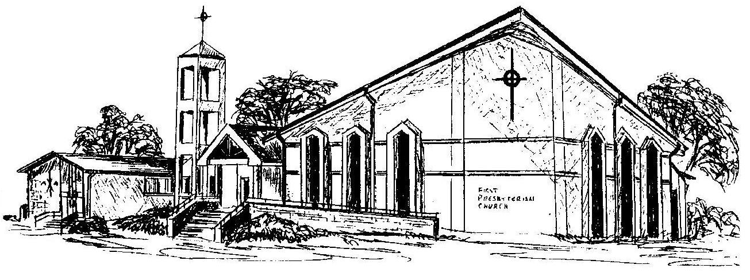

Welcome - Thank you for joining us for worship today. Please fill out a visitor information card found in the pew racks and place those in the offering plate so that we may follow up with you in the future. Your presence with us today has been a blessing to us, we hope that you have felt the presence of God and the welcome of this congregation.

