Welcome
Prelude “ Meditation on "Veni Emmanuel"” Plainsong / arr. by John Scriveyner
Let us prepare our hearts and minds for worship.

Call to Worship and Lighting of the Advent Wreath – Wayne & Alice Rollf
Leader: Jesus said, “I am the Light of the World,
whoever follows me will not walk in darkness, but will have the light of life.”
People: As we light the first candle again in our Advent wreath,
we remember the prophet’s hope based on God’s promise:
To send a Messiah who would bring peace and love to the world.
Leader: As we light the second candle, we remember the peace of Christ
that calms our fears and inspires us to reach out to others,
People: The light reminds us that Christ has come to set our hearts on fire.
Get up and make ready, for Jesus Christ comes.
Leader: Let us prepare for the coming of the Lord.
People: Let us praise Jesus Christ, Light of the World!

*Opening Hymn “Angels We Have Heard on High” Red Hymnal, #145

*Prayer of Confession (Unison)
Prince of Peace, Light in our darkness, help us to hear your message and answer your call. We know your promises come in many ways, yet we look for the familiar, the material, the comforting and the certain. Inspire us to listen and to look beyond the obvious, that we might see your glory and receive your grace, through Jesus Christ who loves us beyond our understanding. Amen.

*Silent Reflection

*Assurance of Pardon

*Gloria Patri (Glory Be to the Father…) Red Hymnal, #62

Children’s Time

Scripture “1 Samuel 2:1-10” (page 420)
“Luke 1:39-55” (page 1589)
Leader: The Word of the Lord.
People: Thanks be to God.
Anthem

Sermon “Songs of Peace” Rev. Kimby Young

*Profession of Faith The Apostle's Creed Red Hymnal, inside back cover
I Believe in God the Father Almighty, Maker of heaven and earth,
And in Jesus Christ his only Son our Lord; who was conceived by the Holy Ghost, born of the Virgin Mary, suffered under Pontius Pilate, was crucified, dead, and buried; he descended into hell; the third day he rose again from the dead; he ascended into heaven, and sitteth on the right hand of God the Father Almighty; from thence he shall come to judge the quick and the dead.
I believe in the Holy Ghost; the holy catholic Church; the communion of saints; the forgiveness of sins; the resurrection of the body; and the life everlasting. Ame

*Hymn “Lo, How a Rose E’re Blooming” Red Hymnal #160

Ordination & Installation of Officers Ginger Crist, Lynn Moldrup, Larry Schick and
Poppy Zurcher Elders. Sandy Nellor, Joseph Kioko, Judy Mason, Shana Devlin, Kelly Johnson Deacons

Pastoral Prayer & Lord’s Prayer

Offertory Meditation: “Of the Father’s Love Begotten”
Plainsong/arr.by C. Winred Douglas

*Doxology

&Prayer of Dedication

*Closing Hymn: “It Came Upon the Midnight Clear” Red Hymnal #128

*Benediction

Postlude “Let There Be Peace On Earth” Sy Miller and Jill Jackson
*Those who are comfortably able will please stand.

Childcare is available in the nursery (off hall west of the sanctuary). Children are welcome to stay in the sanctuary, or to leave at any time. Allison Perry is our primary childcare attendant.

Offering Plates are at the entrance of each aisle for your contributions to the work of the church.

Gardner Multi Service Center collection is ongoing every week and is always in need of any non-perishable food. Bring something every week or once a month.

Fair Trade Products for Sale on Sundays Coffee, tea, chocolate, nuts, olive oil, dried fruit, baking products, and a few other items are for sale each Sunday at church.

Harvesters Food Distribution is always seeking volunteers. Every 3rd Saturday at Trade Net Parking lot and every 4th Wednesday at Divine Mercy Parish. Distribution begins at about 1 p.m.

FPC at the Joy Closet on the 4th Saturday of every month. Come anytime 10:00 – 2:00 p.m.

Joy Closet needs volunteers anyone age 14 and up they can use your help. Stop in and fill out a volunteer card and you will be contacted to set up training.

Choirs meet on Wednesday’s Bell Choir at 6:00 p.m. in Chapel, Chancel Choir at 7:00 p.m. in Sanctuary, Christmas Cantata at 8:00 p.m.

Advent Devotionals are available in the narthex.

Mrs. Claus will visit Sunday School - Sunday, December 10, 10 a.m. Fellowship Hall

Hot Chocolate Tasting - New Fair Trade Products - December 10 - 9:45 to 11 a.m.

Men’s Breakfast on Tuesday, December 12 Perkins at 7:00 a.m.

Cantata - Song of Joy - December 17 - 10 a.m. - one worship service
Children's Christmas Pageant in worship - December 24 - 10 a.m.
Christmas Eve - Worship with candlelight and communion - 4:30 p.m.
New Year's Eve Worship - December 31 - 10 a.m. - one worship service

First Presbyterian Church
In the heart of Gardner since 1866 ~ Serving from the heart of God

Sunday, December 10, 2023
Second Sunday of Advent
8:45 AM

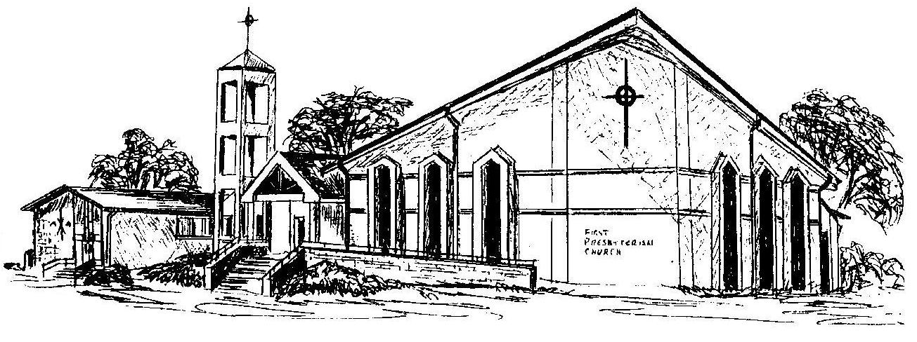

Welcome - Thank you for joining us for worship today. Please fill out a visitor information card found in the pew racks and place those in the offering plate so that we may follow up with you in the future. Your presence with us today has been a blessing to us, we hope that you have felt the presence of God and the welcome of this congregation.

Rev. Kimby Young; Rhonda Atwater , Worship Assistant
Dean Faulk, Music Ministries, Chancel Choir; Alice Rollf, Organist
Mike McGuire and Brad Cornell, Slide Production
Davis Tropansky & Theo Borge, Tech and Videographer; Kim Liu, Sound

