Welcome

Prelude “Ceremonial Rondeau” Henry Purcell / arr. by Rick Parks
Let us prepare our hearts and minds for worship.

Call to Worship
Leader: People of God, rejoice! The Light of the World has come!
People: The light shines in the darkness, and the darkness has not overcome it.
Leader: People of God, give thanks!
We have received this Light of life and are called to share that light in the world.
People: Arise, Shine, Our Light has come!

*Opening Hymn: “We Three Kings” Red Hymnal, # 166, verses 1 & 5

*Prayer of Confession (Unison)
God of light and darkness, we have seen the glimmer of your star-light beckoning to us, but we have turned away and followed other paths. We have heard the wisdom of prophets and sages, but we have ignored their call. We have experienced the glorious grace of our Savior, but we have neglected to tell the good news. Forgive us. Enlighten us again. Empower us to dream. Inspire us to live the love of Jesus and to be witnesses to your love in the world that all may see your glory and come to worship you. Amen.

*Silent Reflection

*Assurance of Pardon
Leader: Even the darkness is not dark to God, and the night is as bright as the day.
People: The God who promised never to leave us or forsake us has come to us in Jesus Christ, Emmanuel, God with us, Light of the World.
Leader: Arise, shine; for your light has come. The glory of the Lord has risen upon you.
People: Our eyes have been opened. By God’s grace, the blind are able to see.

*Gloria Patri (Glory Be to the Father…) Red Hymnal, #623

Children’s Time

Solo “His Love Reaching” Gaithers

Scripture “Matthew 2:1-12” (page 1497)
“John 1:1-5” (page 1645)
“John 8:12” (page 1662)
Leader: The word of the Lord.
People: Thanks be to God.
Sermon: “Seeing the Light; Shining the Light” Rev. Kimby Young

*Profession of Faith The Apostle's Creed Red Hymnal, inside back cover
I Believe in God the Father Almighty, Maker of heaven and earth,
And in Jesus Christ his only Son our Lord; who was conceived by the Holy Ghost, born of the Virgin Mary, suffered under Pontius Pilate, was crucified, dead, and buried; he descended into hell; the third day he rose again from the dead; he ascended into heaven, and sitteth on the right hand of God the Father Almighty; from thence he shall come to judge the quick and the dead.
I believe in the Holy Ghost; the holy catholic Church; the communion of saints; the forgiveness of sins; the resurrection of the body; and the life everlasting. Amen

*Hymn “Be Thou My Vision” Red Hymnal, #382

Offertory Meditation: ”Wonder of Wonders” John W. Peterson

*Doxology

The Sacrament of Holy Communion
(All bread is gluten free. Prepacked elements are available in the back)
Invitation
Great Prayer and The Lord’s Prayer
Words of Institution – Breaking of Bread
Communion of the People
Prayer of Thanksgiving

*Closing Hymn: “O Word of God Incarnate” Red Hymnal, # 269

*Benediction

Postlude: “Light of the World We Hail Thee” Lawrence W. Watson
*Those who are comfortably able will please stand.

Rev. Kimby Young, Pastor; Teri Winegar, Worship Assistant
Dean Faulk, Music Ministries
Alice Rollf, Organist.; Chesley Jones, Soloist
Mike McGuire and Brad Cornell, Slide Production
Theo Borge and Davis Tropansky, Tech; Kim Liu, Sound

Childcare is always available in the nursery (off the hall to the west of the sanctuary). Children are welcome to stay in the sanctuary thru the whole service, or to leave at any time. Allison Perry is our primary childcare attendant.

Offering Plates are at the entrance of each aisle for your contributions to the work of the church.

Gardner Multi Service Center collection is ongoing every week and is always in need of any non-perishable food. Bring something every week or once a month.

Fair Trade Products for Sale on Sundays Coffee, tea, chocolate, nuts, olive oil, dried fruit, baking products, and a few other items are for sale each Sunday at church.

Harvesters Food Distribution is always seeking volunteers. Every 3rd Saturday at Trade Net Parking lot and every 4th Wednesday at Divine Mercy Parish. Distribution begins at about 1 p.m.

2024 Per Capita is $43.29 The allocation breakdown is as follows General Assembly $7.73, Synod $2.80, Presbytery $32.76

Sunday January 28 at 9:45 a.m. Annual Congregational Meeting The session has called a congregational meeting for Sunday, January 28 at 9:45 a.m. The purpose of the meeting is to receive our annual reports from staff, committees, groups and pillars, and to approve the terms of call for pastor Kimby Young.

Good Time to start. New Year. Pastor Kimby's Bible Study – Gospel of John each Thursday, 10-11:30 a.m. resumes January 11.

Ladies! Please join us for rolls and coffee on Saturday, January 13, 2024, at 10:00 a.m. in Fellowship Hall for an overview of upcoming winter Bible study. Bible Study starts on Thursday, February 1 at 7:00 p.m.

Weather Cancellation Policy Usually, we try to worship if possible. We may modify worship or cancel Sunday school. Even if we don’t cancel. Be smart. Be cautious. Don't take any chances. Even if a church event is not cancelled, if you do not feel comfortable getting out, you are excused. If you have a duty, we will find someone to cover for you.

Men’s Breakfast on Tuesday, January 9, 7:00 a.m. at Perkins.

First Presbyterian Church
In the heart of Gardner since 1866 ~ Serving from the heart of God

Sunday, January 7, 2024
Epiphany Sunday
8:45 a.m.

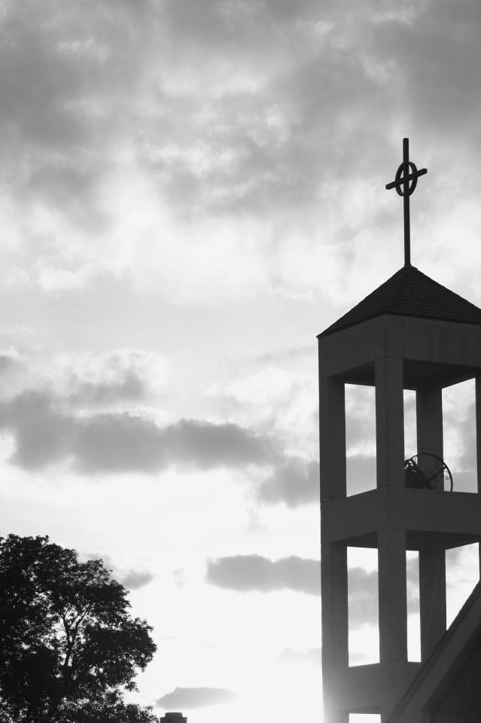

Welcome - Thank you for joining us for worship today. Please fill out a visitor information card and place those in the offering plate so that we may follow up with you in the future. Your presence with us today has been a blessing to us, we hope that you have felt the presence of God and the welcome of this congregation.

