Welcome
Prelude “Be Still, For the Presence of the Lord”
David Evans / arr. by Geoff Baker
Let us prepare our hearts and minds for worship.

Call to Worship (adapted from Lutheran Retreats, Camps, and Conferences.)
Leader: Come and see, come, and see!
People: We come to see for ourselves who this Jesus is.
Leader: We come with open hearts to experience Jesus
People: Come and see, come, and see! We come to follow Jesus.

*Opening Hymn: “Great Is Thy Faithfulness” Red Hymnal, # 43

*Prayer of Confession (Unison)
Great and faithful God, You have called us each by name. Help us to remember and to answer. You have shown us Your love in countless ways. Help us to give thanks and to love others as You have loved us. In Jesus Christ, You have shown us the path to follow. Help us to walk with you through each of our days, to share your love in all of our ways. We pray in the name of Jesus. Amen.

*Silent Reflection

*Assurance of Pardon

* Gloria Patri (Glory Be to the Father…) Red Hymnal, #623

Bell Choir “ I Love To Tell the Story”
Music by William Fischer, arr. by Sharon Elery Rogers

Children’s Time

Scripture “John 1:35-51” (page 1647)
Leader: The word of the Lord.
People: Thanks be to God.

Anthem “Worthy Is Your Name” arr. by Marty Parks

Sermon “Come and See” Rev. Kimby Young

*Profession of Faith The Apostle's Creed Red Hymnal, inside back cover
I Believe in God the Father Almighty, Maker of heaven and earth, And in Jesus Christ his only Son our Lord; who was conceived by the Holy Ghost, born of the Virgin Mary, suffered under Pontius Pilate, was crucified, dead, and buried; he descended into hell; the third day he rose again from the dead; he ascended into heaven, and sitteth on the right hand of God the Father Almighty; from thence he shall come to judge the quick and the dead. I believe in the Holy Ghost;
the holy catholic Church; the communion of saints; the forgiveness of sins; the resurrection of the body; and the life everlasting. Amen

*Hymn “I Am Thine O Lord” Red Hymnal, #358

Pastoral Prayer & Lord’s Prayer

Offertory Meditation “Come and See” Lenny LeBlanc

*Doxology

*Prayer of Dedication

*Closing Hymn: “When I Survey the Wondrous Cross” Red Hymnal, #185

*Benediction

Postlude “Recessional” Stephen Otis
*Those who are comfortably able will please stand.

Rev. Kimby Young, Pastor; Maureen Allinder, Worship Assistant
Dean Faulk, Music Ministries; Alice Rollf, Organist; Chancel Choir
Bell Choir, Mike McGuire and Brad Cornell, Slide Production
Theo Borge, Tech, and Videographer; Kim Liu, Sound

Childcare is always available in the nursery (off the hall to the west of the sanctuary). Children are welcome to stay in the sanctuary thru the whole service, or to leave at any time. Allison Perry is our primary childcare attendant.

Offering Plates are at the entrance of each aisle for your contributions to the work of the church.

Gardner Multi Service Center collection is ongoing every week and is always in need of any non-perishable food. Bring something every week or once a month.

Fair Trade Products for Sale on Sundays Coffee, tea, chocolate, nuts, olive oil, dried fruit, baking products, and a few other items are for sale each Sunday at church.

Harvesters Food Distribution is always seeking volunteers. Every 3rd Saturday at Trade Net Parking lot and every 4th Wednesday at Divine Mercy Parish. Distribution begins at about 1 p.m.

Presbyterian Women Bible Study has begun on Thursdays, at 7:00 p.m.in Fellowship Hall lesson is “Worth More Than Rubies” by Christina Patterson.

Monday Night Bible Study group has started a new study: Angels: 8 Studies for Individuals or Groups, on Feb. 12. This group meets every other Monday evening at 5:30pm via Zoom. If interested, please contact Jennifer Waites (jwaitemail@hotmail.com).

Women’s Bible Study, on Wednesday, March 6, 2024, 10:00 a.m. in Fellowship Hall.

Women’s Bible Study & Brunch on Saturday, March 9 at 9:30 a.m. in Fellowship Hall.

Daylight Saving’s Time begins on Sunday, March 10, move clock one hour ahead.

OGHS collection is collected on March 31, you can ear mark check OGHS.

Mission fundraiser for hygiene kits $5.00, woman/girls health kits $25.00.

Black Out Drapes - For Lent each year we raise curtains over the stained glass windows as reminders of the deepening season. As a Lenten discipline we are called to awareness of light and darkness in the world as we seek God's presence in our daily lives, and as we look forward in hope to the celebration of the resurrection of Jesus Christ

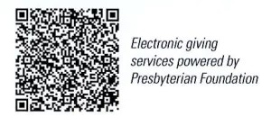
First Presbyterian Church
In the heart of Gardner since 1866 ~ Serving from the heart of God

Sunday, February 25, 2024
2nd Sunday of Lent
8:45 AM
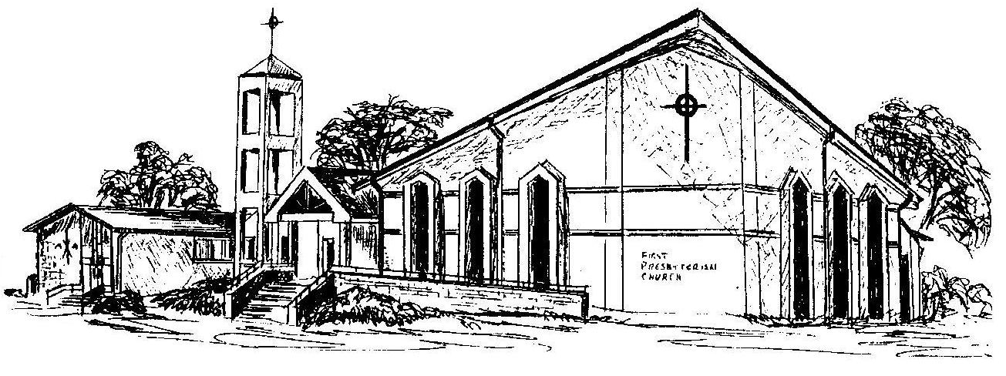

Welcome - Thank you for joining us for worship today. Please fill out a visitor information card found in the pew racks and place those in the offering plate so that we may follow up with you in the future. Your presence with us today has been a blessing to us, we hope that you have felt the presence of God and the welcome of this congregation.

