Welcome

Prelude “Beside Still Waters” Louise E. Stairs
Let us prepare our hearts and minds for worship.

Call to Worship
Leader: The Lord is our shepherd, guiding us to green pastures and still waters.
People: The Lord is our shepherd, providing for our every need.
Leader: God protects us and cares for us, heals us and redeems us.
People: Jesus leads us along the right paths and carries us home.
Leader: Our shepherd calls us each by name. We belong to God and are blessed.
People: Let us worship God.

*Opening Hymn: “All the Way My Savior Leads Me” Red Hymnal, #460

*Prayer of Confession (Unison) (adapted from Rev Karla, at RevGalBlogPals.)
Loving Shepherd, You lead and guide, You walk alongside, You prepare, you feed, you call, all of your sheep, even those of us who are lost, those of us who stray constantly, those of us who stay close to your comforting staff. When we walk in the shadows of fear and despair, forgive us and heal us. When we do not hear your voice, call us again, restore us and carry us home. Loving Shepherd, we are grateful to have all we need, as we live in You. Amen.

*Silent Reflection

*Assurance of Pardon

*Gloria Patri (Glory Be to the Father…) Red Hymnal, #62

Reflection on Psalm 23

Children’s Time

Scripture “Psalm 23” (page 862)
Leader: The Word of the Lord.
People: Thanks be to God.

Anthem “It Is Well with My Soul” John Ness Beck
Sermon “Psalm 23” Rev. Kimby Young

*Profession of Faith The Apostle's Creed Red Hymnal, inside back cover
I Believe in God the Father Almighty, Maker of heaven and earth,
And in Jesus Christ his only Son our Lord; who was conceived by the Holy Ghost, born of the Virgin Mary, suffered under Pontius Pilate, was crucified, dead, and buried; he descended into hell; the third day he rose again from the dead; he ascended into heaven, and sitteth on the right hand of God the Father Almighty; from thence he shall come to judge the quick and the dead.
I believe in the Holy Ghost; the holy catholic Church; the communion of saints; the forgiveness of sins; the resurrection of the body; and the life everlasting. Amen

*Hymn “Wonderful Words of Life” Red Hymnal, #270

Pastoral Prayer & Lord’s Prayer

Offertory Meditation: “The New 23rd” Ralph Carmichael

*Doxology

*Prayer of Dedication

*Closing Hymn: “It Is Well With My Soul” Red Hymnal, #493

*Benediction

Postlude “Exultation” Roger C. Wilson
*Those who are comfortably able will please stand.

Rev. Kimby Young; Lynn Moldrup, Worship Assistant
Dean Faulk, Music Ministries, Chancel Choir
Alice Rollf, Organist
Mike McGuire and Brad Cornell, Slide Production
Davis Tropansky & Theo Borge, Tech and Videographer; Kim Liu, Sound

Childcare is available in the nursery (off hall west of the sanctuary). Children are welcome to stay in the sanctuary, or to leave at any time. Allison Perry is our primary childcare attendant.

Offering Plates are at the entrance of each aisle for your contributions to the work of the church.

Gardner Multi Service Center collection is ongoing every week and is always in need of any non-perishable food. Bring something every week or once a month.

Fair Trade Products for Sale on Sundays Coffee, tea, chocolate, nuts, olive oil, dried fruit, baking products, and a few other items are for sale each Sunday at church.

Harvesters Food Distribution is always seeking volunteers. Every 3rd Saturday at Trade Net Parking lot and every 4th Wednesday at Divine Mercy Parish. Distribution begins at about 1 p.m.

Our church is serving at the Joy Closet on the 4th Saturday of every month. Just show up anytime between 10:00 – 2:00 p.m.

Women’s Bible Study meets every Thursday, at 6:30 pm in Westminster Room. We are studying the book Desperate for HOPE by Vaneetha Risner.

Choirs meet on Wednesday’s Bell Choir at 6:00 p.m. in Chapel, Chancel Choir at 7:00 p.m. in Sanctuary, Christmas Cantata at 8:00 p.m.

Sunday School for all ages. 10:00 a.m. Children & Youth classes meet downstairs.

Book Club 6:30 p.m. at Perkins on Friday, October 27 “An Undivided Heart” Book 3.

Trunk or Treat – Sunday, October 29 5:00 -7:00 p.m. Sign up in the narthex to help.
5:00 – 5:45 p.m. Trick-or-treat and Games in North Parking Lot
5:45 – 7:00 p.m. Chili Supper in Fellowship Hall

Monday online Bible Study 6 p.m. on October 30, contact Jennifer Waites for login information. jwaitemail@hotmail.com.

Ladies Night Out hosted by Presbyterian Women Thursday, November 2 at 6:30 p.m. Potluck Bring a salad to share. Making Thanksgiving wreaths for shut ins, friends or yourself.

Daylight Savings Time Ends– Sunday November 5, don’t forget to move your clocks back one hour, so you will make it to church on time.

Give Thanks to the Lord, Stewardship Dedication Sunday, November 12. Financial Support, time, talents, property and prayer. You can bring pledge cards to service, both services.

Operation Christmas Child Packing Party – November 12 – 9:45-11 a.m.
YOU ARE ALL INVITED TO A PACKING PARTY for Operation Christmas Child.
First Presbyterian Church
In the heart of Gardner since 1866 ~ Serving from the heart of God

Sunday, October 22, 2023
8:45 AM

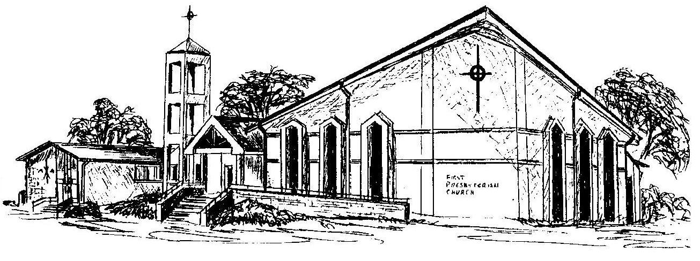

Welcome - Thank you for joining us for worship today. Please fill out a visitor information card found in the pew racks and place those in the offering plate so that we may follow up with you in the future. Your presence with us today has been a blessing to us, we hope that you have felt the presence of God and the welcome of this congregation.

