Welcome

Prelude “Worship” James Southbridge
Let us prepare our hearts and minds for worship.

Call to Worship
Leader: In the beginning, God’s Spirit moved over the waters.
People: Even today, the Spirit of God moves through water to remind us of God’s grace.
Leader: In baptism, we are touched by God’s Spirit, enfolded in a community of grace, and empowered to go forth sharing God’s love in the world.
People: Let us celebrate God’s grace, remembering our baptisms and accepting our call to serve God in Jesus Christ our Lord.

*Opening Hymn “Amazing Grace” Red Hymnal, #202

*Prayer of Confession (Unison) ) (adapted from Stephen Fearing, Wild and Precious Life.)
God of our baptismal waters, You sent John the Baptist to point to Your Son, and You sent Your Son who pointed always to You. But too often, we point only to ourselves or our own concerns. Forgive us, Lord, for pointing in all the wrong directions. Hold our gaze on your baptismal promise sealed in the life, death, and resurrection of your Son. Through the power of your Spirit, give us the courage to speak what we have seen and point to the One who takes away the sins of the world. In the name of your son, Jesus Christ, we pray. Amen.

*Silent Reflection

*Assurance of Pardon

*Gloria Patri (Glory Be to the Father…) Red Hymnal, #62

Children’s Time

Scripture “Mark 1: 4-11“ (page 1551)
Leader: The Word of the Lord.
People: Thanks be to God.

Anthem

Sermon “Remembering Baptism” Rev. Kimby Young
*Profession of Faith The Apostle's Creed Red Hymnal, inside back cover
I Believe in God the Father Almighty, Maker of heaven and earth,
And in Jesus Christ his only Son our Lord; who was conceived by the Holy Ghost, born of the Virgin Mary, suffered under Pontius Pilate, was crucified, dead, and buried; he descended into hell; the third day he rose again from the dead; he ascended into heaven, and sitteth on the right hand of God the Father Almighty; from thence he shall come to judge the quick and the dead.
I believe in the Holy Ghost; the holy catholic Church; the communion of saints; the forgiveness of sins; the resurrection of the body; and the life everlasting. Amen

*Hymn “Take My Life and Let It Be” Red Hymnal, #379 verses 1,5,6

Reaffirmation of Baptism Covenant:
Trusting in the gracious promises of God, do you renounce sin and the power of evil in your life and in the world?
Do you turn again to Jesus Christ and accept Jesus as your Lord and Savior?
Do you intend to be Christ's faithful disciple, obeying God’s Word, showing God’s love and sharing God’s grace in the world?

Pastoral Prayer & Lord’s Prayer

Offertory Meditation: “When Jesus Came to Jordan” William Walker

*Doxology

*Prayer of Dedication

*Closing Hymn: “Have Thine Own Way Lord” Red Hymnal, #371

*Benediction

Postlude “A Time for New Beginnings” Lani Smith
*Those who are comfortably able will please stand.

Rev. Kimby Young; Lynn Moldrup, Worship Assistant
Dean Faulk, Music Ministries, Chancel Choir; Alice Rollf, Organist
Mike McGuire and Brad Cornell, Slide Production
Davis Tropansky & Theo Borge, Tech and Videographer; Kim Liu, Sound

Childcare is always available in the nursery (off the hall to the west of the sanctuary). Children are welcome to stay in the sanctuary thru the whole service, or to leave at any time. Allison Perry is our primary childcare attendant.

Offering Plates are at the entrance of each aisle for your contributions to the work of the church.

Gardner Multi Service Center collection is ongoing every week and is always in need of any non-perishable food. Bring something every week or once a month.

Fair Trade Products for Sale on Sundays Coffee, tea, chocolate, nuts, olive oil, dried fruit, baking products, and a few other items are for sale each Sunday at church.

Harvesters Food Distribution is always seeking volunteers. Every 3rd Saturday at Trade Net Parking lot and every 4th Wednesday at Divine Mercy Parish. Distribution begins at about 1 p.m.

2024 Per Capita is $43.29 The allocation breakdown is as follows General Assembly $7.73, Synod $2.80, Presbytery $32.76

Sunday January 28 at 9:45 a.m. Annual Congregational Meeting The session has called a congregational meeting for Sunday, January 28 at 9:45 a.m. The purpose of the meeting is to receive our annual reports from staff, committees, groups and pillars, and to approve the terms of call for pastor Kimby Young.

Weather Cancellation Policy Usually, we try to worship if possible. We may modify worship or cancel Sunday school. Even if we don’t cancel. Be smart. Be cautious. Don't take any chances. Even if a church event is not cancelled, if you do not feel comfortable getting out, you are excused. If you have a duty, we will find someone to cover for you.

Scripture for Upcoming Worship
January 14 – Baptism of Jesus – Mark 1:4-11.
January 21 – First Miracle – John 2:1-11.
January 28 – Healing Miracles – John 5:1-15; John 9:1-7

First Presbyterian Church
In the heart of Gardner since 1866 ~ Serving from the heart of God

Sunday, January 14, 2024
Baptism of the Lord Sunday
8:45 AM

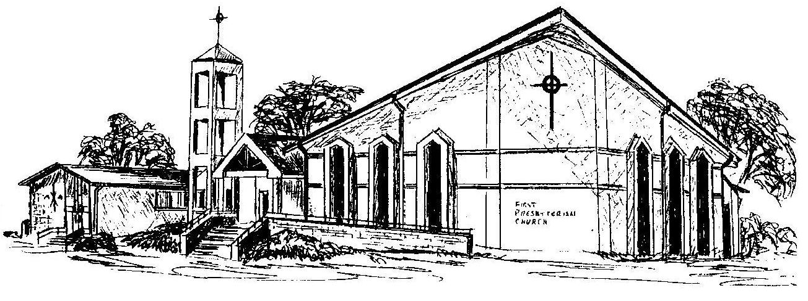

Welcome - Thank you for joining us for worship today. Please fill out a visitor information card found in the pew racks and place those in the offering plate so that we may follow up with you in the future. Your presence with us today has been a blessing to us, we hope that you have felt the presence of God and the welcome of this congregation.

