Welcome

Prelude “Because I Have Been Given Much” Phillip Landgrave
Let us prepare our hearts and minds for worship.

Call to Worship
Leader: In this season of Thanksgiving, we turn to God in gratitude and joy.
People: We praise God for all of God’s gifts to us.
Leader: Today we celebrate God’s provision and God’s presence in our lives.
People: Today we pledge our trust in God, and we place our lives in God’s hands.

*Opening Hymn “We Gather Together” Red Hymnal, #561

*Prayer of Confession (Unison)
Sovereign Lord of the Universe, we recognize your power in the world. Yet we sometimes fail to see your presence in our lives. We do not yield to you our moments or trust you with our fears. We hold back when we should let go. Reach into our hearts with your mercy and help us to place our lives in your hands. Amen.

*Silent Reflection

*Assurance of Pardon

*Gloria Patri (Glory Be to the Father…) Red Hymnal, #62

Children’s Time

Scripture “Psalm 100” (page 937)
“Ephesians 1:15-23” (page 1818)
“1 Thessalonians 5:16-18” (page 1841)
Leader: The Word of the Lord.
People: Thanks be to God.

Anthem “My Tribute”
Words and music by Andrae; arr. Ed Lojeski

Sermon “Thanks In All Circumstances” Rev. Kimby Young

*Profession of Faith The Apostle's Creed Red Hymnal, inside back cover
I Believe in God the Father Almighty, Maker of heaven and earth,
And in Jesus Christ his only Son our Lord; who was conceived by the Holy Ghost, born of the Virgin Mary, suffered under Pontius Pilate, was crucified, dead, and buried; he descended into hell; the third day he rose again from the dead; he ascended into heaven, and sitteth on the right hand of God the Father Almighty; from thence he shall come to judge the quick and the dead.
I believe in the Holy Ghost; the holy catholic Church; the communion of saints; the forgiveness of sins; the resurrection of the body; and the life everlasting. Amen

*Hymn “Come Ye Thankful People Come” Red Hymnal, #559

Pastoral Prayer & Lord’s Prayer

Offertory Meditation: “Ave Verum” Wolfgang Amadeus Mozart

*Doxology

Prayer of Dedication with PW Thank Offering and Mitten Tree Dedication
– adapted from PW Resources (Unison)
Gracious God, we give you thanks for providing for our every need: food, shelter, wisdom, skill, friendship, affection. We remember that these gifts come from you and are meant to be shared. Creator, Giver, for all of this, we thank you. Bless these Thank Offering gifts and our Mitten Tree Warm items as they touch the lives of others. Bless the children who will benefit. Bless the women who will have greater access to resources. In the name of the One who responded with unbounded love and generosity, Jesus Christ our Savior. Amen.

*Closing Hymn: “For the Beauty of the Earth” Red Hymnal, #560 vs 1, 3 & 5

*Benediction

Postlude “We Plow the Fields”
Johann A.P. Schulz / arr. Joseph Prentiss
*Those who are comfortably able will please stand.

Rev. Kimby Young; Karen Elliott, Worship Assistant
Dean Faulk, Music Ministries, Chancel Choir; Alice Rollf, Organist
Mike McGuire and Brad Cornell, Slide Production
Davis Tropansky & Theo Borge, Tech and Videographer; Kim Liu, Sound
Childcare is available in the nursery (off hall west of the sanctuary). Children are welcome to stay in the sanctuary, or to leave at any time. Allison Perry is our primary childcare attendant.

Offering Plates are at the entrance of each aisle for your contributions to the work of the church.

Gardner Multi Service Center collection is ongoing every week and is always in need of any non-perishable food. Bring something every week or once a month.

Fair Trade Products for Sale on Sundays Coffee, tea, chocolate, nuts, olive oil, dried fruit, baking products, and a few other items are for sale each Sunday at church.

Harvesters Food Distribution is always seeking volunteers. Every 3rd Saturday at Trade Net Parking lot and every 4th Wednesday at Divine Mercy Parish. Distribution begins at about 1 p.m.

FPC at the Joy Closet on the 4th Saturday of every month. Come anytime 10:00 – 2:00 p.m.

Joy Closet needs volunteers anyone age 14 and up they can use your help. Stop in and file out a volunteer card and you will be contacted to set up training.

Choirs meet on Wednesday’s Bell Choir at 6:00 p.m. in Chapel, Chancel Choir at 7:00 p.m. in Sanctuary, Christmas Cantata at 8:00 p.m.

Congregational Meeting, Sunday, November 26 9:40 a.m. Session has called a congregational meeting for the purpose of electing officers for 2024. Elder nominees include Ginger Crist, Lynn Moldrup, Larry Schick, and Poppy Zurcher. Deacon nominees are Sandy Nellor, Joseph Kioko and Judy Mason, as well as Shana Devlin and Kelly Johnson renewing for a second term. Nominating Committee members at large 2024 to be elected are Paula Waters, Larry Atwater, Robin Tropansky, Phil Lenahan, and Lois Barber.

Presbyterian Women have up the Mitten Tree. Please bring scarves, gloves, mittens, winter items. They will be delivered to different Gardner schools.

Presbyterian Women Holiday “High Tea” on Saturday, December 2nd at 2:00 pm, in the home of Poppy Zurcher. Join us for food and fellowship; cookie exchange and white elephant exchange. Sign up in the Narthex by Thanksgiving!!

Christmas Poinsettias for Sanctuary cost $13.00 in memory of or in honor of someone special due by Monday, December 4.

No Children’s Sunday School on Sunday, November 19th and November 26th.
First Presbyterian Church
In the heart of Gardner since 1866 ~ Serving from the heart of God

Sunday, November 19, 2023
8:45 AM

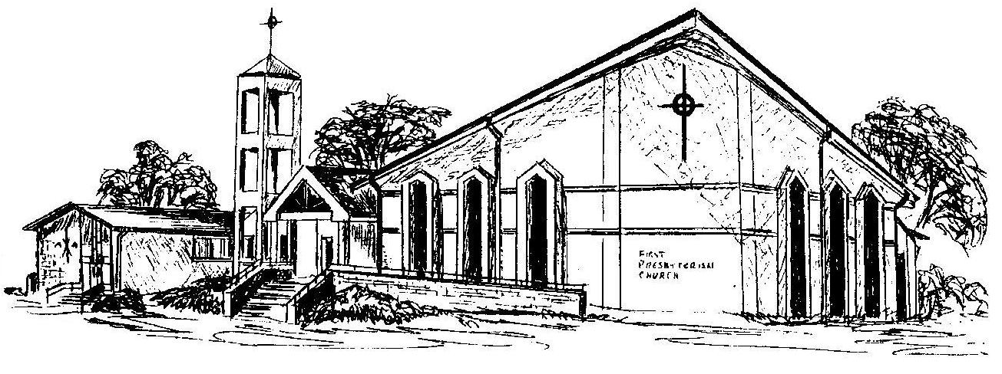

Welcome - Thank you for joining us for worship today. Please fill out a visitor information card found in the pew racks and place those in the offering plate so that we may follow up with you in the future. Your presence with us today has been a blessing to us, we hope that you have felt the presence of God and the welcome of this congregation.

