Welcome
Prelude “To God Be the Glory” William H. Doane
Let us prepare our hearts and minds for worship.

Leader: People will come from east, west, north and south, to sit at table in the presence of God.
People: We gather – men and women, boys and girls, old and young, feeble and strong – to praise God and to celebrate God’s gifts.
Leader: Come, let us worship God freely and fully together.
People: Let us hear God’s Word and respond to Christ’s call.

*Opening Hymn: “Holy, Holy, Holy” Red Hymnal, #266

*Prayer of Confession (Unison)
God of Miracles, we confess that sometimes we fail to believe. We trust what we see and know. We even trust what we fear, more than what you promise. In the presence of your abundance, we still hold back. Forgive us. Nourish us. Fill us again with all that you offer, that we may respond with generosity and joy, in the name of Jesus Christ our Savior. Amen.

Silent Reflection

*Assurance of Pardon
Leader: God says, “Ask and you will receive. Seek and you will find.”
People: God has opened doors for us, even beyond our asking.
Leader: Friends, hear and believe the good news of God’s grace.
People: All things are possible through Jesus Christ who gives us everything we need.

* Gloria Patri (Glory Be to the Father…) Red Hymnal, #623

Children’s Time

Scripture “John 6: 1-15” (page 1655)
“John 6: 35” (page 1657)
Leader: The word of the Lord.
People: Thanks be to God.

Anthem “Come to the Table”
Words & Music by Ben McDonald, Dave Frey and arr. by David Wise

Sermon “Fed By Jesus” Rev. Kimby Young

*Profession of Faith The Apostle's Creed Red Hymnal, inside back cover
I Believe in God the Father Almighty, Maker of heaven and earth, And in Jesus Christ his only Son our Lord; who was conceived by the Holy Ghost, born of the Virgin Mary, suffered under Pontius Pilate, was crucified, dead, and buried; he descended into hell; the third day he rose again from the dead; he ascended into heaven, and sitteth on the right hand of God the Father Almighty; from thence he shall come to judge the quick and the dead. I believe in the Holy Ghost; the holy catholic Church; the communion of saints; the forgiveness of sins; the resurrection of the body; and the life everlasting. Amen

*Hymn “Break Thou the Bread of Life” Red Hymnal, #274 verses 1,2,3

Offertory Meditation: “I Will Bless the Lord” Frank Hernandez

*Doxology

The Sacrament of Holy Communion
(All bread is gluten free. Prepacked elements are available in the back.)
Invitation
Great Prayer and The Lord’s Prayer
Words of Institution – Breaking of Bread
Communion of the People
Prayer of Thanksgiving

*Closing Hymn: “Lord Speak to Me That I May Speak” Red Hymnal, #450

*Benediction

Postlude “Fill His Courts with Praise” Elizabeth T. Van Woert
*Those who are comfortably able will please stand.

Rev. Kimby Young, Pastor; Oliver Schwab, Worship Assistant
Dean Faulk, Music Ministries, Alice Rollf, Organist; Chancel Choir
Mike McGuire and Brad Cornell, Slide Production
Theo Borge, Tech and Videographer; Kim Liu, Sound

Childcare is always available in the nursery (off the hall to the west of the sanctuary). Children are welcome to stay in the sanctuary thru the whole service, or to leave at any time. Allison Perry is our primary childcare attendant.

Offering Plates are at the entrance of each aisle for your contributions to the work of the church.

Gardner Multi Service Center collection is ongoing every week and is always in need of any non-perishable food. Bring something every week or once a month.

Fair Trade Products for Sale on Sundays Coffee, tea, chocolate, nuts, olive oil, dried fruit, baking products, and a few other items are for sale each Sunday at church.

Harvesters Food Distribution is always seeking volunteers. Every 3rd Saturday at Trade Net Parking lot and every 4th Wednesday at Divine Mercy Parish. Distribution begins at about 1 p.m.

2024 Per Capita is $43.29 General Assembly $7.73, Synod $2.80, Presbytery $32.76.

Souper Bowl Sunday February 11 Bring non-perishable food anytime.
Noisy Offering on Sunday, February 11 is going to Souper Bowl Sunday.

Ash Wednesday, February 14 Worship Service is 7:00 p.m. Drive through 5:30- 6:30 p.m.

Presbyterian Women Bible Study has begun Thursdays, at 7:00 p.m.in Fellowship Hall lesson is “Worth More Than Rubies” by Christina Patterson.

Monday Night Bible Study group is starting a new study: Angels: 8 Studies for Individuals or Groups, on Feb. 12. This group meets every other Monday evening at 5:30pm via Zoom. If interested, please contact Jennifer Waites (jwaitemail@hotmail.com).

Lenten Devotion Books in narthex, adult “Take Up Your Cross”. The children & family book is “Walking in His Ways.”

Men’s Breakfast on Tuesday, February 13, Perkins at 7:00 a.m.
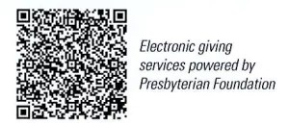
First Presbyterian Church
In the heart of Gardner since 1866 ~ Serving from the heart of God

Sunday, February 4, 2024
8:45 AM
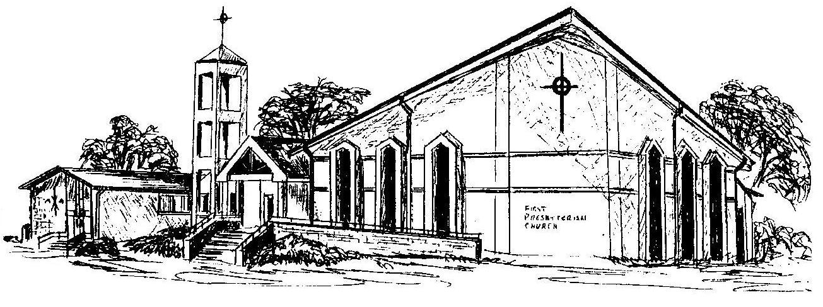

Welcome - Thank you for joining us for worship today. Please fill out a visitor information card found in the pew racks and place those in the offering plate so that we may follow up with you in the future. Your presence with us today has been a blessing to us, we hope that you have felt the presence of God and the welcome of this congregation.

